The Title Goes Here With Each Initial Letter Capitalized Max. 80 Characters Including Blanks (Font: Arial, 18, Bold; Remove Blue text)
Presenting Author's Name^{1,*} and Author's Name^{1,2} (Font: Arial, 14)
1 Replace this text with authors' affiliations (use complete addresses)
2 Continue Here (Font: Arial 10)
* email of corresponding author (Font: Arial 10)

ABSTRACT (Font: Arial, 11, Bold)
This is the standard font (Arial, 11) and layout for the individual paragraphs. The style is called "Paragraph." Replace this text with your text. Please underline the name of the presenting author. You must send a Word version of this abstract. If you submit your abstract as an editable source file in a different format than this template (Word file), it is highly recommended that you send also (in addition) a PDF version of it to ensure that all symbols are reproduced correctly [1], but in order to maintain the uniformity in the printed version before submitting them please make sure that it is formatted as closely as possible to the provided model. -Use maximum one page for the abstract.
This is the paragraph spacing that occurs when you use the Enter key. Below is an example equation created with Word 97’s Equation Editor. To move this equation, highlight the entire line, then use cut and paste to the new location. To use this as a template, select the entire line, then use copy and paste to place the equation in the new location.
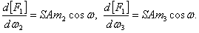 (1)
You are welcome to include figures in your abstract

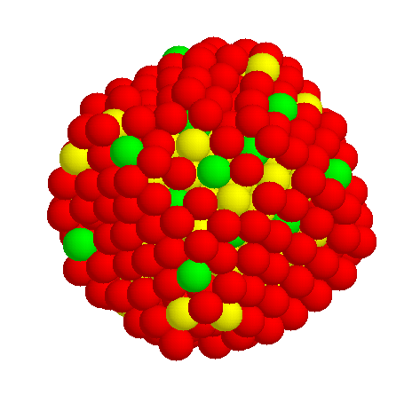  Fig. 1 : Please, include figure with 600dpi resolution minimum. | 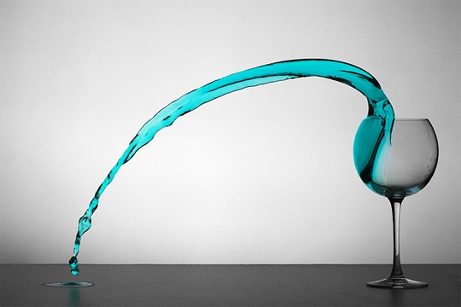  Fig. 2 : Figure 2 (Font: Arial, 8, Italic)

To insert a footnote, use the "Insert" menu, select "Footnote", and click "OK."
Remove Blue text
End of the abstract text

References (Font: Arial, 11, Bold)
1. M. P. Brown and K. Austin, Appl. Phys. Letters 85, 2503-2504 (2004).
2. R. T. Wang, “Title of Chapter,” in Classic Physic, edited by R. B. Hamil, Publisher City: Publisher Name, 1999, pp. 212-213.
(Font: Arial, 7,5)

